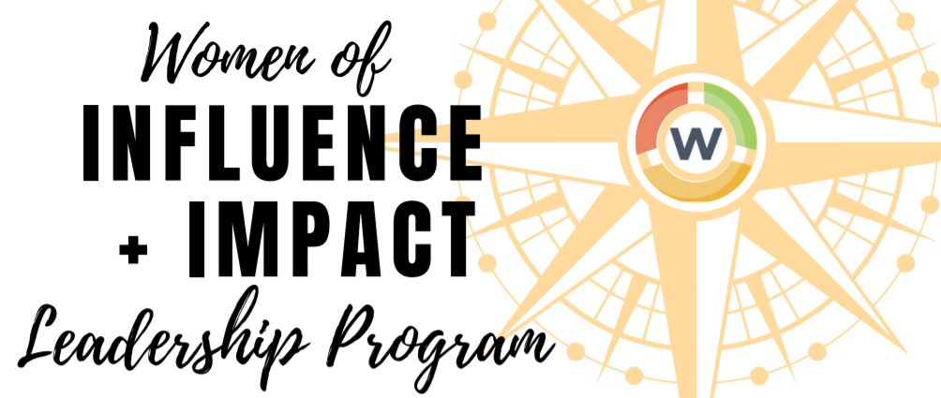
We need more female leaders at the highest levels of leadership.
As leaders, women are still struggling to get to the very top. Only 14% of CEO's in large organizations are held by women, and Colorado is nearly last in the nation for the number of women on publicly traded boards.
The CWCC is working to change these statistics… And we need more dynamic leaders like you.
Join the 2021-2022 CWCC Women of Influence and Impact Leadership program that is designed to help emerging leaders in manager to director level type roles to grow their influence in the community, develop their leadership skills, and build their network.
This program has three key components to develop leaders:
- Curriculum: Gain key leadership skills that women need in order to advance from experts and industry leaders, such as: negotiation, board service, strategic alignment, and leading with authenticity and vulnerability.
- Community: Participants will work with a nonprofit that serves women and execute on a project to give them a better understanding of what challenges that people in our community are faced with.
- Industry: Get a deeper understanding of industries and how they impact our economy and how women are impacted in industries such as healthcare, government, and male- dominated fields.
Leaders who have gone through the program say…
“Who I am, who I become, what path I choose and how I live my life has been altered and defined by this group and I can't express my gratitude enough for what that means. I had been looking for something like this and when it fell into my lap I couldn't sign up fast enough and it has STILL far exceeded my expectations.” – Caroline Arendall, Class of 2019-2020
“I’ve definitely grown more confident in my own leadership skills in the few months of participating in the CWCC’s Women of Influence and Impact. I’ve been forced out of my comfort zone on several occasions and that has given me the confidence to venture out of my comfort zone back at work.”
— Jessica Hudgins, Goodwill Industries of Denver, Class of 2017-2018
“One of the best parts of the program was the ability to connect with other like-minded, inspirational women!” — Jennifer Case, Vectra Bank, 2018 - 2019
WOMEN OF INFLUENCE AND IMPACT 2020-2021 APPLICATION
Applications must be received by August 13th, 2021. Follow up interviews will be scheduled as applications are received. Submit applications to Heather Howerton, Director of Strategic Marketing and Operations, hhowerton@cwcc.org.

Program Expectations: The class meets 1x/month on a Friday 8:30 – 4:30pm, October - June. You are expected to be present for the full day. There will be breaks throughout the day to make calls, catch up on emails, etc. In order to graduate the program, you cannot miss more than two classes. There will be homework sent prior to meeting for you to learn about speakers, and topics related to the day.

Class Project: There are group projects involved in this program where the class is divided into groups. To accomplish your project, you will need to meet outside of class with your group. The time outside of class depends on the project (approximately 5-10 hours/month).

Meeting: This program will take place in person. If needed, we may have a day that is virtual, but otherwise plan to be in person. We will meet at locations across the Denver Metro Area and may move locations in the same day. You will be notified in advanced of where we will be meeting.

NAME:
TITLE/POSITION:
COMPANY:
EMAIL:
PHONE:

Describe your current position and responsibilities.

What motivated you to apply for the leadership program?

Have you participated in a leadership program before? Whether yes or no, what aspects of this program really resonate with you?

What are 1-2 career highlights or achievements you have experienced in the last 2-3 years?

What are your top three leadership challenges?

What is one professional goal you have and what do you need to achieve it?
What other affiliations (e.g., service or volunteer organizations) are you a part of? Describe your role/duties (if applicable) and any awards or recognition you have received.

What do you hope to gain from the leadership experience?

What do you hope to contribute to the program?

Do you need scholarship assistance? If so, how much of the total cost do you need assistance with?
We will work to support scholarship needs to the best of our availability.
Please initial your agreement to the following policies:
____ I have a current CWCC membership or will become a member to participate in the program. Please note – must be an active CWCC member to participate in the program.
____ I agree not to miss more than TWO classes during the program or leave early/arrive late more than twice.
_____I agree to the $2,500 investment to participate or my membership dues includes one seat in this program (through scholarship, organization/self-payment)
Please submit a brief bio and headshot along with your application.
Please submit your application to Leah Caputo, Lcaputo@cwcc.org, by August 13th.

